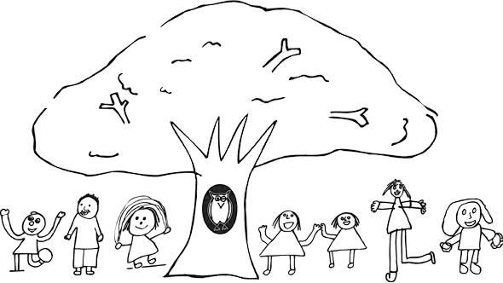
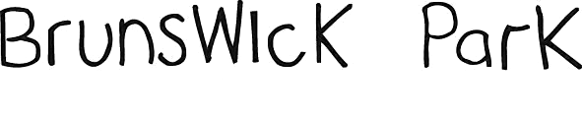

The Early Years
Foundation Stage Booklet

Reception
2025-26

Phone: 020 8368 3468
Email: office@brunswickpark.barnetmail.net
Website: https://brunswickparkbarnet.co.uk/

A message from our Executive Head Teacher

Dear Parents and Carers,

We would like to offer you the warmest welcome to Brunswick Park Primary and Nursery School and especially to the Early Years Foundation Stage. I hope your child’s first days here will be the beginning of a long and happy time with our school. This will be the start of our educational partnership together with you and your child.

We believe active learning is the best learning. The wide variety of experiences is carefully planned to help all the children explore and learn, interact with each other, develop self-confidence and co-operate.

We need you to be active in your child’s school experience and to be a partner in the learning journey. We always welcome your help and will encourage your participation along the way.

Please take your time to read this booklet carefully as it will provide you with lots of useful information to help you as you get to know the school routines and develop your partnership with our staff.

Wishing you many happy and successful years ahead together.

Yours sincerely,

Andy Griffiths
Executive Head Teacher

The Curriculum
We aim to work together with you and follow the principles of The Early Years Foundation Stage 2021 (EYFS) in Nursery and Reception. Through this curriculum we provide quality and consistency so that, every child makes good progress and has a secure foundation of learning. The partnership between practitioners and parents through equality of opportunity are central to this success.

We use Educational Programmes and incorporate the Characteristics of Effective Learning (Playing and Exploring, Active Learning and Creating and Thinking Critically) to provide high quality first hand experiences and play so that, children can reach their potential and grow in a happy, stimulating and supportive community. We provide a calm and secure environment where a positive attitude is encouraged and children are enabled to learn lifelong skills and independence.

Educational Programmes:

Prime Areas
Communication and Language | Listening, Attention and Understanding  Speaking
Physical Development | Gross Motor Skills  Fine Motor Skills
Personal, Social and Emotional Development | Self-Regulation  Managing Self  Building Relationships

Specific Areas
Literacy | Comprehension  Word Reading  Writing
Mathematics | Number  Numerical Patterns
Understanding the World | Past and Present  People, Culture and Communities  The Natural World
Expressive Arts and Design | Creating with Materials  Being Imaginative and Expressive

Equal Opportunities
All our children have access to the curriculum regardless of their race, gender, cultural or ethnic background. We are totally opposed to racism, bullying and we avoid any stereotyping. Copies of school policies relating to equal opportunities are available on our website.

Reception Classes
We have two classes of approximately 30 pupils in Reception who are able to enjoy their learning together in the inside and outside environment. Each class has a Teacher and member of support staff, and first aiders are always available. The children free-flow between both classrooms and the outside area to play and learn. We provide a range of first hand experiences to explore, ask questions, talk, listen, turn take and share. Each child has individual needs and each child will follow their unique pathway to learning. Children are helped to assess risks and know how to manage them in different situations.

Arrival, Attendance and Home time
Our day begins at 8:50am when you will say goodbye to your child, and they will come inside to hang up their coats, put their lunch bags on the trolley and their book bags in their house group box. No child should be left unattended in the playground.

It is important that you arrive on time each day. You should also be on time to collect your child at 3:15pm. If you are running late, please telephone the school so that we can reassure your child. If someone new is coming to collect your child please tell us beforehand or telephone the school. We will not let your child go with someone we do not know about in advance.
Arrival | 8:50am | When the bell rings, your child will come straight into the Reception building, and their classroom.
Home time | 3:15pm | Please wait outside the Reception building on the main playground in the designated area. The children will be dismissed from their classrooms.

See separate settling in dates and times for September.

Birthdays
We like to celebrate all children’s birthdays at school. Children can bring in fruit or small individual cakes/sweet packets that will be shared at the end of the day to take home – this is optional. Please note we are a nut-aware school, so are unable to give out products that contain/may contain nuts. Alternatively, if you would like to donate a book or your child’s favourite story that would be greatly appreciated.

If you do not wish for your child’s birthday to be celebrated, please speak to a member of staff.

If your child has any allergies or food intolerances, you can provide some suitable alternatives which we can keep at school, and give them in place of a birthday sweet when it is not appropriate.

Book bags
Your child needs to bring their book bag to school every day with their books and reading diaries inside. They will bring home a free choice book from our book corner each week, and a phonetically decodable reading book when appropriate.

Extended Day Provision
Breakfast club - Children will be collected from breakfast club and then taken to their classroom.
Club | Time
Breakfast Club | From 7:30am
After School Club | 3:30-4:30  4:30-5:30
Extended Club  (Bookable in advance ONLY) | Until 6pm

If siblings attend, there will be a £1 discount.

Please contact the school office to gain further information.

Home visits and Stay and Play sessions
These dates and times have been pre-allocated. Your child’s Teacher and member of support staff will visit you at home for approximately 20minutes. This is an opportunity for us to meet you and your child before they start school in a relaxed way, and answer any questions you may have. Stay and Play sessions are an opportunity for your child to familiarise themselves with their new school, with you.

Homework
We will send home the phonics that has been taught at school for you to follow up and support your child with. In addition, at times they will take home a writing task to complete and return the following week.

Lunch
Children will have either a packed lunch or a school dinner. You can swap between a school dinner and a packed lunch during the Autumn term. During the Spring and Summer terms, your lunch preferences will need to be fixed for a half term. Children eat in the hall and then go out to play until 12:45pm. Dedicated Meal Time Supervisors help the children during the lunch time (approx. 11:45am-12:45pm). Reception staff bring the class over to the hall each day, help them choose their lunch, and stay with their class until 11:45am.

If your child is having packed lunch please ensure it is in a named packed lunch box. We encourage healthy eating and are a nut aware school. Any nuts, chocolate spread, peanut butter, nut products, chocolates, sweets or fizzy drinks will be returned to you.

As of September 2014 all children in Reception, Year 1 and Year 2 are eligible for free school meals. Menus are available from the school office.

Medicine, Feeling Unwell and First Aid
Medication - Medicine (both prescription and non-prescription) can only be administered to a child where written permission for that particular medicine has been obtained from a parent/carer. This must be completed at the school office. Prescription medicines will not be administered unless they have been prescribed for your child by a doctor, dentist, nurse, or pharmacist.

Asthma pumps and spacers / EpiPens - must be provided in a named container with your child’s and a completed medical form (available from the school office).

Vomiting and Diarrhoea – Children should stay off school for 48 hours from the last time they vomited or had diarrhoea.

If your child requires any first aid or medical attention, they will take home a first aid letter at the end of the day. If your child sustains a low-risk bump on the head, we will send you a text to notify you so that you can keep an eye on them when they return home. In the event that your child bumps their head and as a result a bump or mark has appeared, we will call you to let you know.
- Please telephone the school to tell us if your child is unwell and will not be coming to school.
- If your child is unwell at school, we will contact you so that you can collect them.
- If your child has a high temperature, they should stay at home.
- Further information can be found at ‘Is my child too ill for school?’ - https://www.nhs.uk/live-well/is-my-child-too-ill-for-school/
- Please ensure your emergency contact details are up to date.
Milk, Fruit and Water
Children are offered fresh fruit/vegetables each day, provided by the government scheme to encourage children to eat ‘five a day’. Children are encouraged to peel their own fruit to
assist with their self-care skills. Milk is also provided for free for all under 5s. If your child
does not drink cow’s milk, you are able to provide an alternative (please label this with your child’s name).

At times, we provide different snacks such as breadsticks, crackers and cheese.

If anyone would like to contribute a healthy snack for the children, this is greatly appreciated (must not contain nut products including sesame)

You will need to provide a refillable named water bottle for your child each day.

Parent/Carer Consultations
Parent/Carer meetings are held throughout the year, where you will be invited to meet with the staff working with your child to discuss their achievements and next steps. We are also available throughout the term to meet with you more informally.

Parent Teacher Association (PTA)
We look forward to working with you and hope you will take an active part in our school life. The Parents and Teachers Association organise many successful and exciting events throughout the year and are always looking for new members.

They can be contacted at Brunswick Park PTA brunswickparkpta@gmail.com.

Parking
If you have to travel to school by car there are two carparks close by that offer ample parking if you get there early enough. They are located on Osidge Lane (opposite East Walk and West Walk) and on Brunswick Park Road (next to Brunswick Park Medical Practice and Osidge Library).

Please do no park on the double yellow lines or on the roundabout on the service road leading up to the staff carpark as this can delay any emergency vehicles.

Phonics
Phonics is a way of teaching children how to read and write. It helps children hear, identify and use different sounds that distinguish one word from another in the English language. Through the programme of Essential Letters and Sounds (ELS) we teach the graphemes (letter shapes) and phonemes (letter sounds) of English. Phonics will start in the autumn term with daily phonics sessions. Each term we will send home the phonics that has been taught at school. This enables you to support your child to practise what they have earnt, including some high frequency words and sentences to read and being to write.

Each half term we will individually assess your child’s phonic knowledge. After the assessments we will let you know how you can continue to support your child at home.

Physical Education
Once your child in in school full time, we will begin PE. On their PE day (TBC), children will come to school wearing their PE kit. Please help your child to be as independent as possible by encouraging them to get dressed/undressed independently, including having a go at doing up and undoing buttons.

A full PE kit includes red shorts, white t-shirt, plain black tracksuit bottoms, plain black tracksuit top and a pair of black or white trainers (with a Velcro fastening). Please name all items of clothing.

Reading
We encourage children to develop a love of books and other reading materials in lots of ways, including enjoying books with you at home. Each week we will change your child’s free choice book with them. After we have begun our phonics teaching, we will also send home a book that your child will begin to read to you. These books need to be kept in your child’s book bag, and will be changed by a member of staff each week. Please read with your child daily, and ensure that you have written at least one comment in your child’s reading diary each week.

Reception Baseline Assessment (RBA)
The RBA is a short, interactive and practical assessment of your child’s early literacy, communication, language and mathematics skills when they begin school. The RBA is not about putting your child under any pressure. They child cannot ‘pass’ or ‘fail’ the assessment. Its main purpose is to create a starting point to measure the progress schools make with their pupils. The data from the assessment will only be used by the Department for Education when your child has reached the end of year 6, to provide the baseline to measure the progress of your child’s year group from Reception to year 6.

We will undertake the RBA with your children one-to-one, within their first six weeks of school

More information can be found here ‘Reception baseline assessment: information for parents’ https://www.gov.uk/government/publications/reception-baseline-assessment-information-for-parents

Tapestry – Online Learning Journal
Tapestry is password protected online learning portal that and can be accessed via their website or the free app https://eylj.org/. All children in Reception have an individual online learning journal which records photos, videos, observations and comments, in line with the Early Years Foundation Stage. This builds up a record of your child’s achievements and experiences during their time with us.

Each class will also have an information account to share class notices and other important information. We will share activities we have done in Reception more easily, giving you greater opportunities to extend your child’s learning at home.

If your child has a Tapestry account at a Nursery, please let us know so that we can merge the accounts.
We encourage you to use Tapestry to see all the amazing learning that has taken place, and to upload your own experiences from home. Tapestry enables you to comment on our observations and add your own, so you can show us what your child is doing outside the school day – weekend trips, exciting learning opportunities, and trips to the shops and follow up school activities etc. This can be done through photos, videos and comments. Please speak to a member of staff if you experience any difficulties accessing Tapestry or need any further support.

Timetable
The timetable below is an outline of what a full day in Reception will look like (timings may differ slightly). The taught carpet time sessions incorporate the Prime and Specific areas of learning and development (see p2) with phonics being taught daily. Registration and direct carpet time teaching is done in base classes, and choosing time is where all children can free-flow between both Reception classrooms and the outdoor learning environment.

Morning routine |  | Afternoon routine
8:50-9:30am | Registration and taught carpet time | 12:45-1:20pm | Registration and taught carpet time
9:30-11:00am | Choosing time / Focus Groups | 1:20-2:45pm | Choosing time / Focus Groups
11:00-11:30am | Carpet time | 2:45-3:15pm | Story time
11:30am-12:45pm | Lunch time (eating lunch and playground time) | 3:15pm | Home time
Uniform and Clothing
You can order uniform, PE kit, book bags and directly from Smiths Schoolwear https://www.smithsschoolwear.co.uk.

Local supermarkets also stock basic items such as cardigans, dresses, jumpers, polo-shirts, shirts, skirts and trousers. Your child will also need a plain black pair of shoes (no trainers or boots). As we encourage all children to be as independent as possible, we ask that their shoes have Velcro fastenings and not shoe laces. In the warmer months white or black sandals with a secure strap around the ankle may be worn.

Wellington boots - Your child will need a pair of named wellington boots in a named bag to keep at school so that they can go outside in all weathers.

Spare clothes – Please provide a full set of spare clothes for your child, including a spare sets of pants/knickers and socks in their bag. This should be in a named bag on their peg. Should your child need to get changed during the school day they can change into their spare clothes. Please make sure their clothes are replenished as soon as possible if worn home.
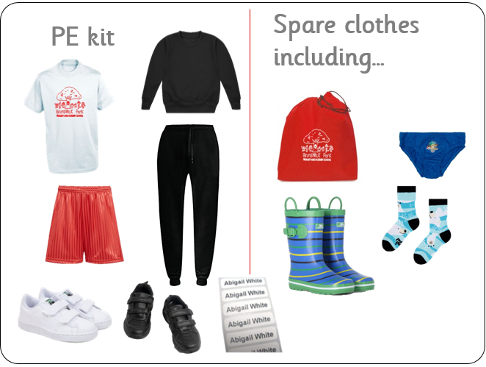
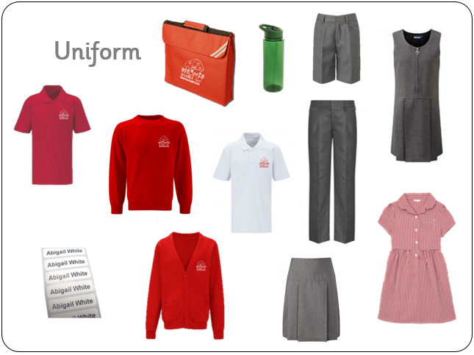

Please ensure that all personal items are clearly labelled with your child’s name, including book bag, water bottle, coat and wellington boots.

Working Together
Our partnership with you is vital and you can help in lots of ways:
- Ensure your child attends daily and on time with the correct named clothing and equipment.
- Provide a refillable named water bottle for your child.
- Make regular contributions to Tapestry (your child’s online learning journal)
- Complete weekly phonics follow up tasks at home with you child and support them with their writing homework.
- Read to your child regularly and support them to read to you every day, and write a comment in their reading diary each week.
- Talk to a member of staff if you have any questions or concerns as we are here to help and support you.
- Donate £5 per full term or 50p a week towards our cooking, playdough ingredients and additional resources etc.
- Make occasional healthy food donations for our snack table.
- Offer to read a story to the class just before home time as a Secret Storyteller.

